**Practical No. 3**

**Aim:** Installation and Creation of Database and Collection.

**Steps:**

1.Download MongoDB executable .msi file from the site [MongoDB Download Centre](https://www.mongodb.org/downloads). Select the latest version for Windows 10.

2. Then navigate to your downloads folder and double click on the .msi package you just downloaded. This will launch the installation wizard.

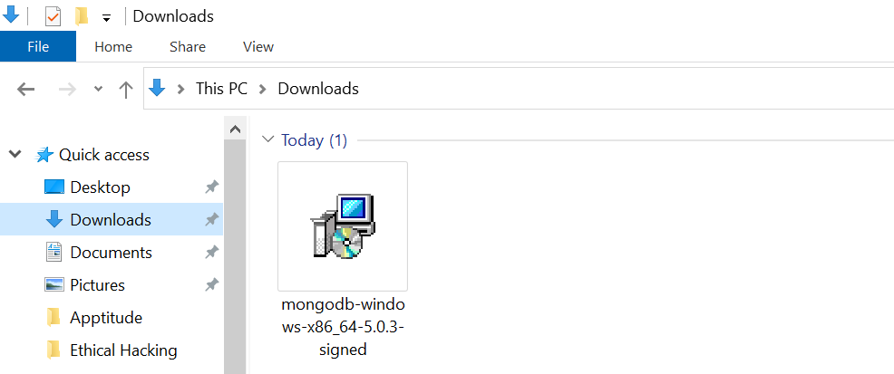

3. Click Next to start installation.

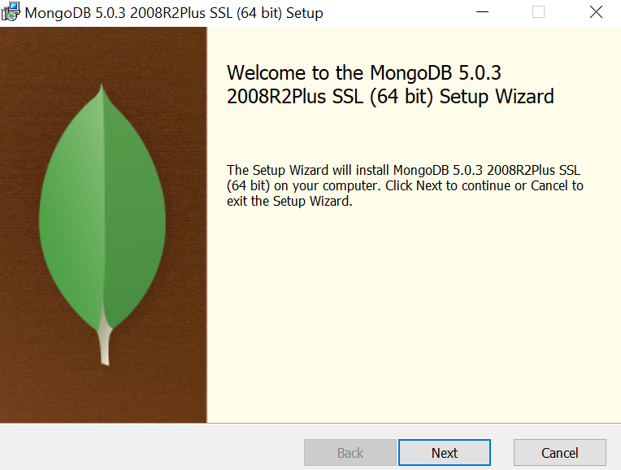

4. Accept the licence agreement then click Next.

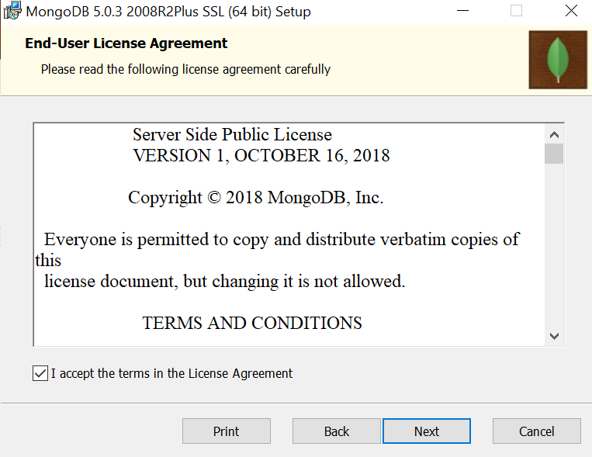

5. Select the Complete setup.

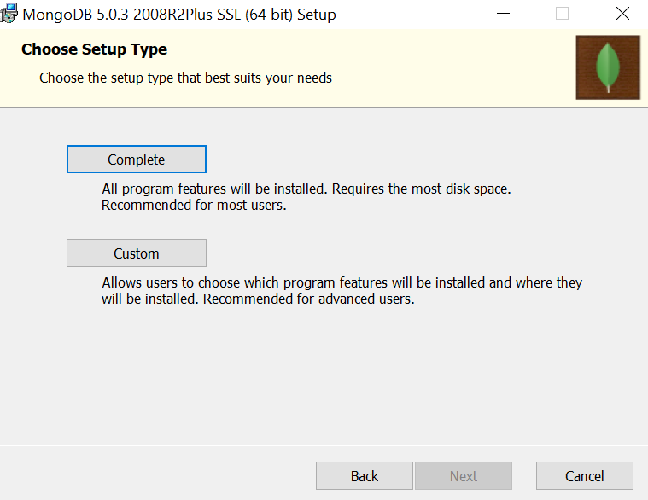

6. Select “Run service as Network Service user” and make a note of the data directory, we’ll need this later.

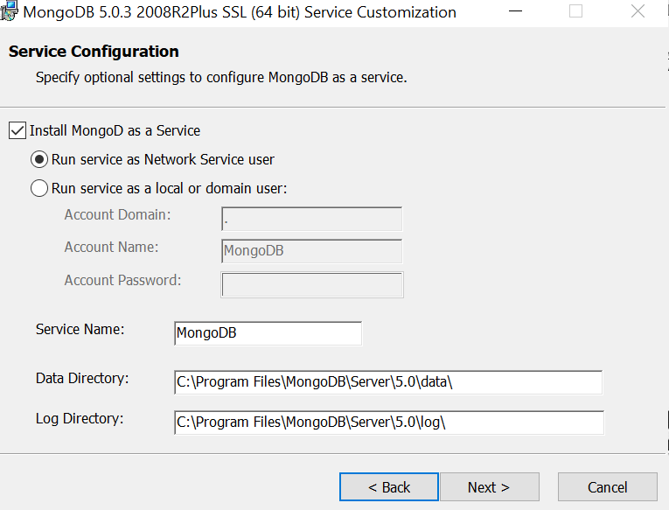

7. We won’t need Mongo Compass, so deselect it and click Next.

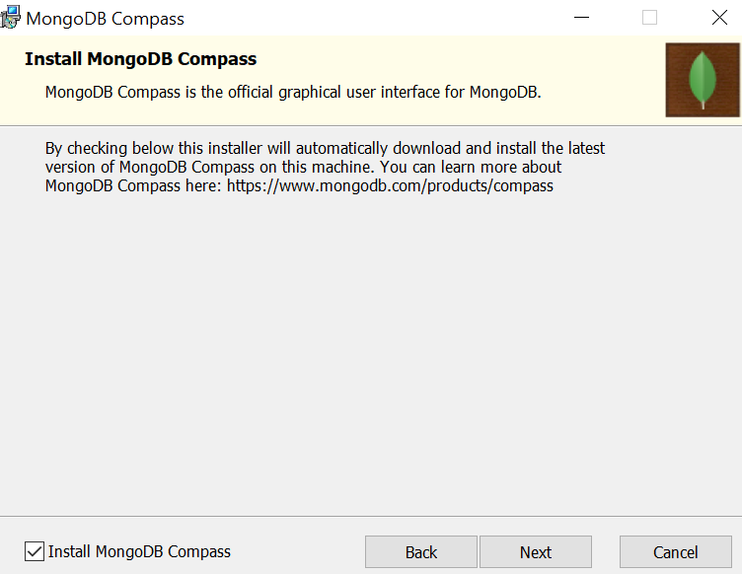

8. Click Install to begin installation.

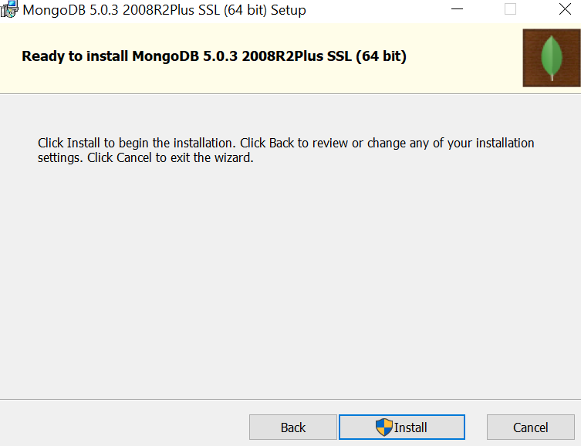

9. Hit Finish to complete installation.

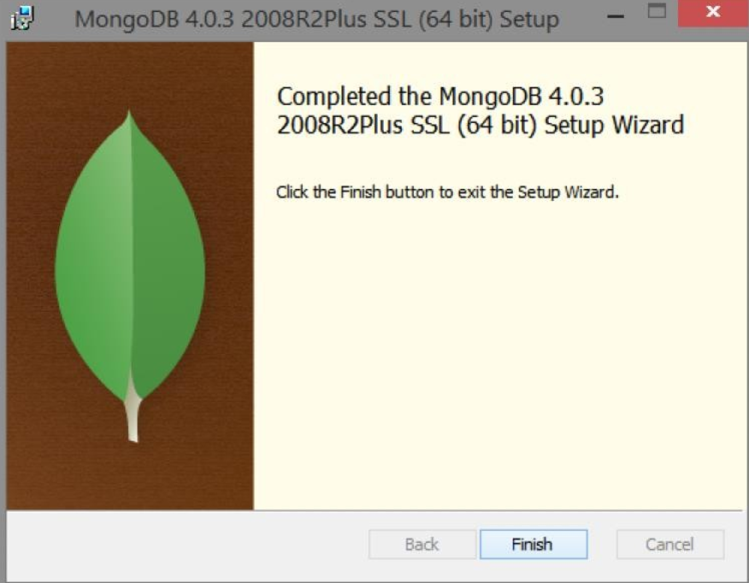

10. It is required to set up the MongoDB environment. MongoDB stores all its data under the folder data\db. It is best practice to create this directory under the folder where the MongoDB is installed. So let's create a folder named data.

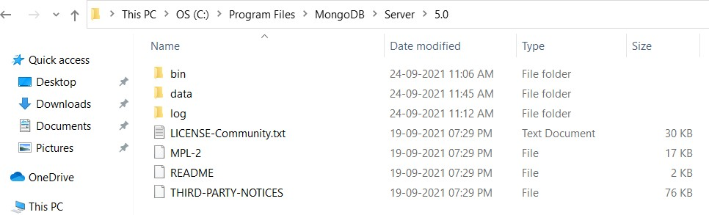

11. Create an environment variable for the executable file so that you don’t have to change the directory structure every time you want to execute the file.

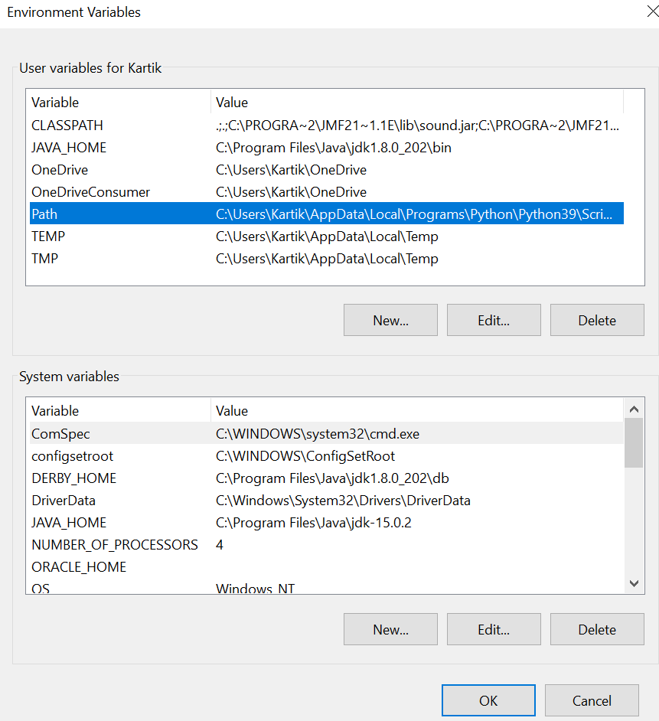

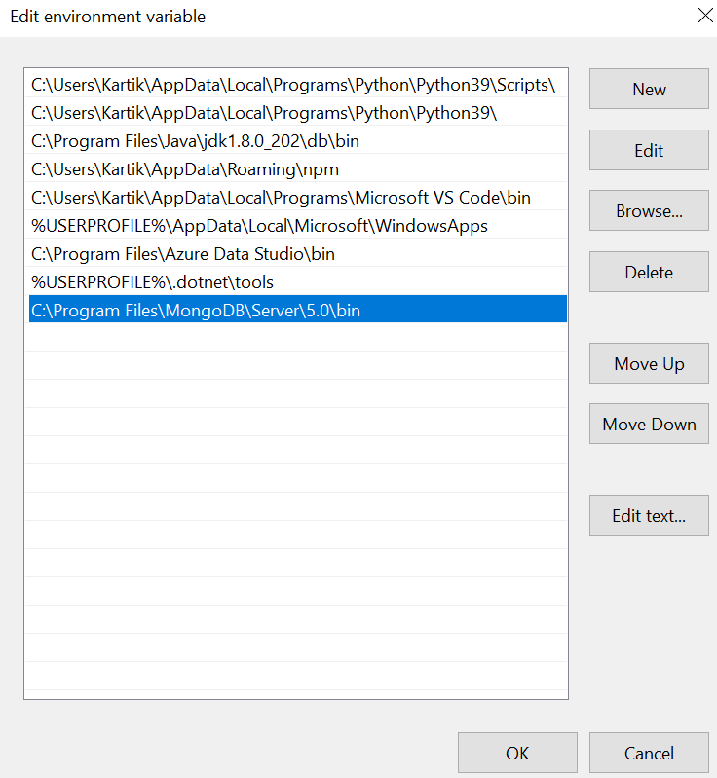

12. After creating an environment path, you can open the command prompt and just type in mongo and press enter.

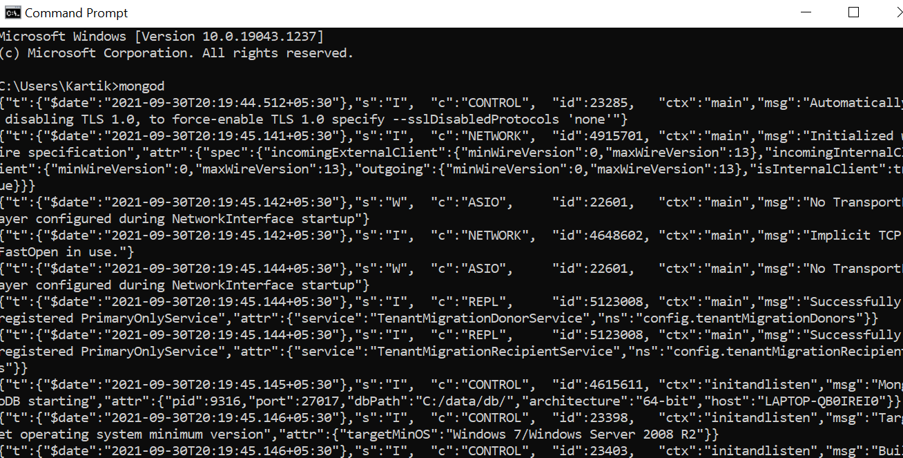

13. The mongo server is then generated and is up and running.

14. To verify if it did the setup correctly, type in the command show DBS.

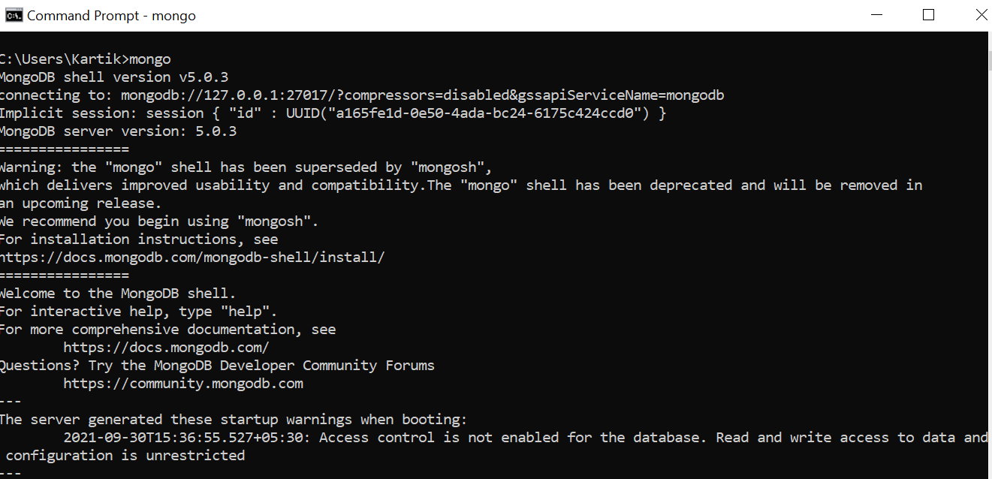

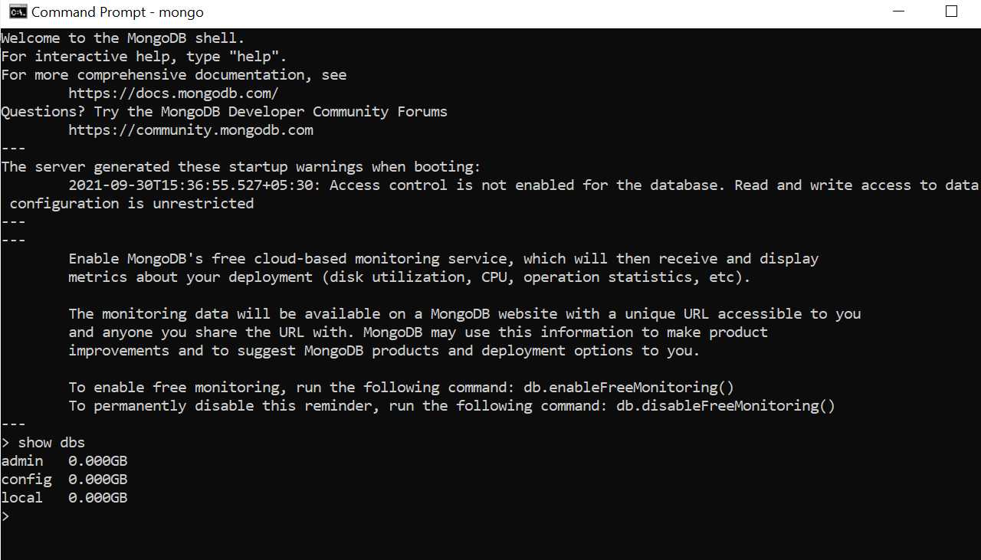

15. With that, you have successfully installed and set up MongoDB on your Windows system.

**Creation of Database and Collection.**

* Create Database

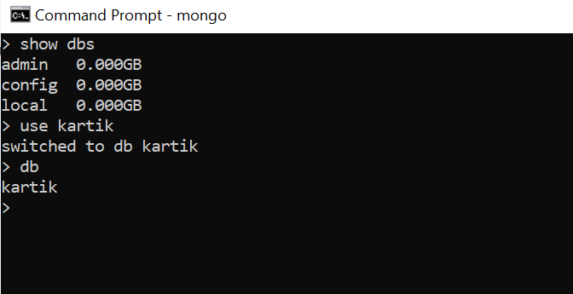

* Create Collection

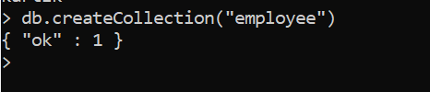

**CRUD Operations: Insert, Query, Update and Delete Operations**

* Insert document

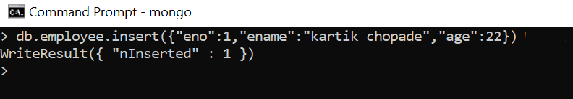

* Query document

1. Find ()

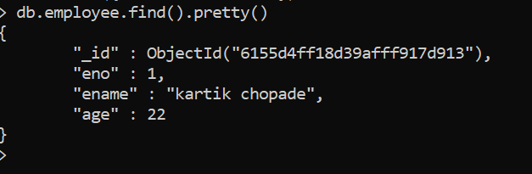

1. Findone ()

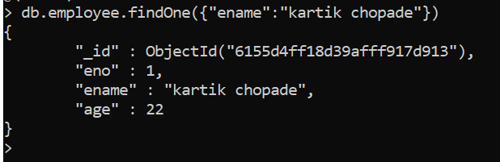

* Update document

1. Update ()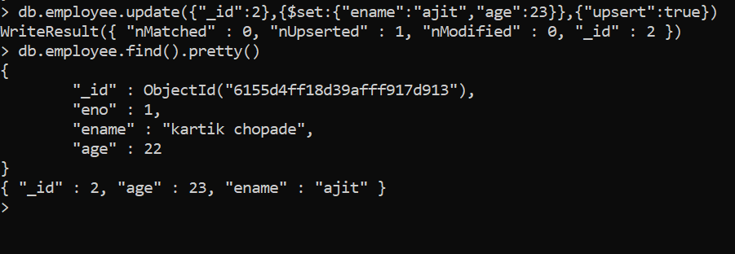
2. UpdateMany ()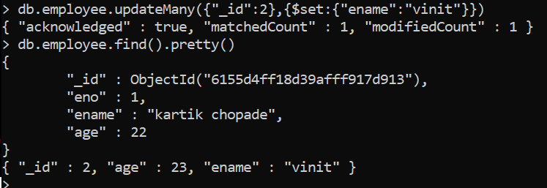

* Delete document

1. Deleteone ()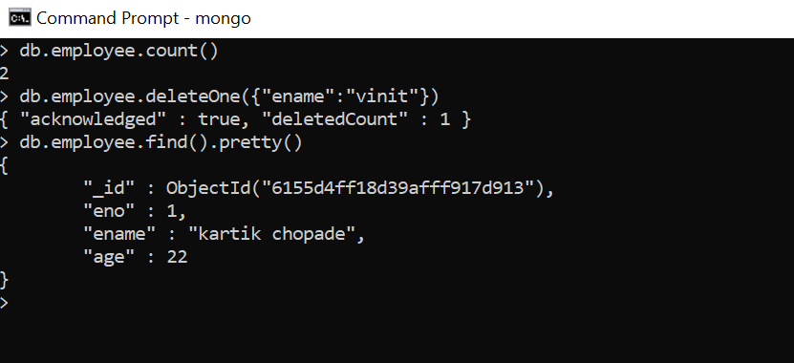
2. Deletemany ()

